Name: _______________________ Class ____________ Date

*Ratios, Rates, Proportions, and Percents Review*

**Ratios/Rates:**

1) A _______________ is a comparison of two numbers by division, written as a : b *or* a to b *o*r.

2) A ratio that compares quantities measured in different units is a _________________________.

3) _____________________ is a rate with a denominator of 1.

* Two examples of this type of rate would be __________________ & __________________.

* To find this special rate, simply divide the ________________ by the ________________.

4) A ________________________ is when two ratios are set equal to each another.

5) There are 7 teachers and 10 students. What is the ratio of teachers to students?

(1) 7:10 (2) 10:7

(3) 17:10 (4) 10:17

6) There are 7 teachers and 10 students. What is the ratio of students to people?

(1) 7:10 (2) 10:7

(3) 17:10 (4) 10:17

7) John jogged 8 miles in 85 minutes. Find his unit rate per minute. Round to the *nearest tenth.*

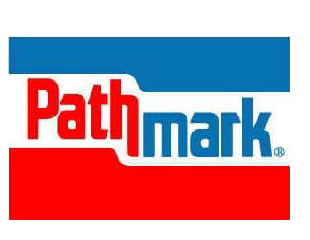8) Pathmark sells 10 ounces of orange juice for $2.40. What is the cost *per ounce*?

9) Shopping at the Waldbaums supermarket you see that there are two different sizes of your favorite cereal, Honey Nut Cheerios. The small size was 9 ounces for $1.70 and the large size was 15 ounces for $2.50. Which is the better buy?

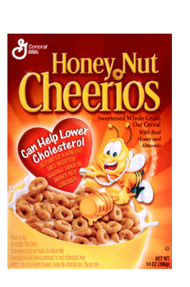

**Proportions:**

\**Remember*: Proportions with binomials 🡪 parentheses 🡪 to help remind you to distribute.

10) Do the following ratios form a proportion? Justify your answer.

,

11) Solve for *x*: =

12) Nicole’s aerobics class exercises to fast-paced music. If the rate of the music is 120 beats per minute, how many beats would there be in a class that is 0.75 hours long?

(1) - 2 (3) - 10

(2) - 3(4) - 15

13) A plane can fly 162 miles in 18 minutes. How far can it fly in 33 minutes?

14) Solve for *x*: $\frac{x+2}{6}$ = $\frac{x-1}{12}$ (BONUS QUESTION)

**Percents**

Percent Formulas:

** or** 

Percent of Change:

 **or** 

|  |  |
| --- | --- |
| 15) What percent of 49 is 7? | 16) 64.2% of 84 is what number? |
| 17) 20% of what number is 72? | 18) What is 25% of 16? |

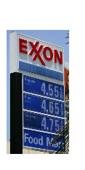

19) In New York the average price for a gallon of regular gas in December of 2007 was $3.26. In one year’s time the price per gallon dropped to $2.08. What is the percent of change?

\**Remember*: **Tax** is ***bad*** for the consumer, so ***add***

20) Tara bought a jacket for $32.50 at Hollister. The sales tax was 8.625%. How much will she pay in sales tax? What is the total cost for the jacket?

\**Remember*: **Discount** is ***good*** for the consumer, so ***subtract***

21) Discount

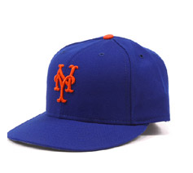a) On Saturday, Michael went to the Lids store in the mall with a $5 gift card. Being that the Mets are the best team in MLB, Michael of course wanted to buy the Mets hat originally priced at $25.00. If the tax is 8.625%, how much did Michael have to spend on the hat after the discount?

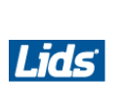b) On Sunday, Lex went to the Lids store because they were having a 15% off sale on all Mets hats (not Yankees hats). Lex liked the same Mets hat Michael liked, but paid a different amount for it. The original price of the hat was $25.00. If the tax is 8.625%, how much did Lex have to spend on the hat after the discount?

c) Who received the better deal? Explain your answer.

22) At Sole, you order Fried calamari for $11.95 and Mezza Rigatoni for $14.95. The sales tax is 8.625%. You plan on tipping 20%, how much will you end up paying?

23) Mr. Art needed to take out a loan for $12,500 for his Nissan Sentra. If he takes 4 years to pay off the loan at a rate of 5.5%, how much will he pay in interest at the end of the 4 years?