Name: _________________________________ 7th Grade Test 7.RP/7.NS
1. A 9-meter roll of blue ribbon costs $13.95. What is the unit price in dollars per meter? (7.RP.A.1)
A. $1.55 B. $2.03 C. $1.45 D. $13.86

2. If Mr. King purchases 198 donuts for his class and there are 18 boxes of donuts, how many donuts are in each box? (7.RP.A.1)
A. 10 B. 11 C. 12 D. 13

3. Erica took a total of 6 quizzes over the course of 3 weeks at school. At this rate, how many quizzes will Erica take at the end of 9 weeks? (7.RP.A.1)
A. 9 B. 12 C. 18 D. 24

4. James bakes 24 cookies with 2 cups of flour. With 8 cups of flour left, how many more cookies can James bake? (7.RP.A.1)
A. 26 B. 48 C. 96 D. 120

5. What missing number would make these ratios be proportional? (7.RP.A.2)
2 to 4 = to 16
A. 4 B. 8 C. 12 D. 16
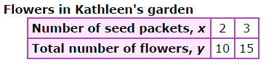
6. The following table shows how the number of seed packets Kathleen purchases is related to the number of flowers she grows. How many flowers can Kathleen grow with each pack? (7.RP.A.2)
A. 5 flowers B. 2 flowers C. 10 flowers

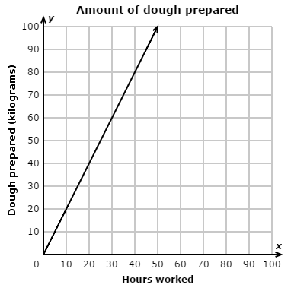
7. This graph shows the relationship between the dough prepared by a baker and the hours it took to prepare the dough.

How many killograms per hour can the baker prepare? (7.RP.A.2)
A. 2 kg per hour B. 4 kg per hour
C. 20 kg per hour D. 80 kg per hour

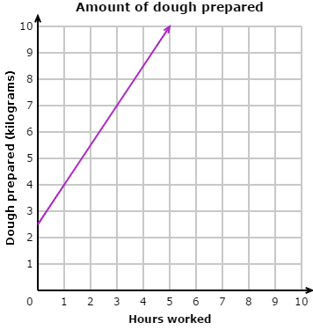
8. Does this graph represent a proportional relationship? (7.RP.A.2)

A. Yes B. No

9. Write an equation for the data contained in this table. (7.RP.A.2)
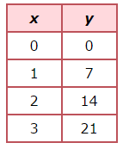
A y = 14x B: y = 7x

C. $x=7y$ D. None of the above

10. Which is the better buy? (7.RP.2)
A. 4 oz bag of coffee for $8.52
B. 9 oz bag of coffee for $19.26?

11. What is the percent of change from 4 to 5? (7.RP.3)
A. 25% increase B. 22% decrease
C. 22% increase D. 25% decrease

12. What is the percent of change from 50 to 85? (7.RP.3)
A. 76% increase B. 76% decrease
C. 70% increase D. 70% decrease

13. What is the opposite of the number 5? (7.NS.1)
A. 5 B. |5| C. |-5| D. $-5$

14. What is the value of |-85|?
A. 85 B. -85 C. zero D. 170

15. What is the value of $g$ on this number line? (7.NS.1)
A. 0.5 B. 0.9 C. 0.75 D. 1

16. Which sign makes this number sentence true? (7.NS.1)
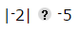
A. < B. > C. =

17. Which sign makes this number sentence true? (7.NS.1)
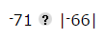 A. < B. > C. =

18. A recipe for making 4 cups of soup requires 3 cups of water. At this rate, how many cups of water are required to make 24 cups of soup? (7.RP.2)
A. 6 cups B. 18 cups C. 32 cups D. 96 cups

19. Solve for $x.$ $\frac{5}{11}= \frac{x}{44}$ (7.NS.A.2)
A. 39 B. 38 C. 40 D. 20

20. At 10:57am a submarine was at a depth of - 160 feet. Its depth then changed at a rate of -8 feet per minute. What was its depth at 11:03am? A. -48 feet
B. -112 feet C. -162 feet D. -208 feet

21. On Monday, the low temperature in Bristol was -5◦ Fahrenheit. On Tuesday, the low temperature was 14◦ Fahrenheit. How many degrees warmer was the low temperature on Tuesday than on Monday in Bristol?
-19◦ Fahrenheit B. -9◦ Fahrenheit C. 9◦ Fahrenheit D. 19◦ Fahrenheit

22. A garden hose leaks $\frac{3}{8}$ gallon of water in $\frac{1}{4}$ hour. At this rate, how many gallons of water will the hose leak in 1 hour?
$A. \frac{3}{32}$ gallon B. $\frac{5}{8}$ gallon C. $1\frac{3}{8}$ gallons D. $1\frac{1}{2}$ gallons

23. What is the value of the expression $\frac{2}{3}\left(6-\frac{5}{6}\right)$?
A. $3\frac{1}{6}$ B. $3\frac{4}{9}$ C. $4\frac{4}{9}$ D. $4\frac{5}{6}$

24. Greta donates the same amount to a certain charity each year. This graph shows the relationship between the total amount she has donated and the number of years she has been making donations.
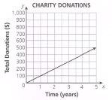

What does the point (1, 100) on the graph represent?
A. Every year Greta donates $1.
B. Every year Greta donates $100.
C. Every 10 years Greata donates $1.
D. Every 10 years Greata donates $100.

25. A hairstylist earns a 25% commission on each haircut she does. One customer received a $35 haircut and gave the stylist an 18% tip. What was the total amount the stylist earned on this haircut?
A. $6.30 B. $8.75 C. $10.33 D. $15.05

